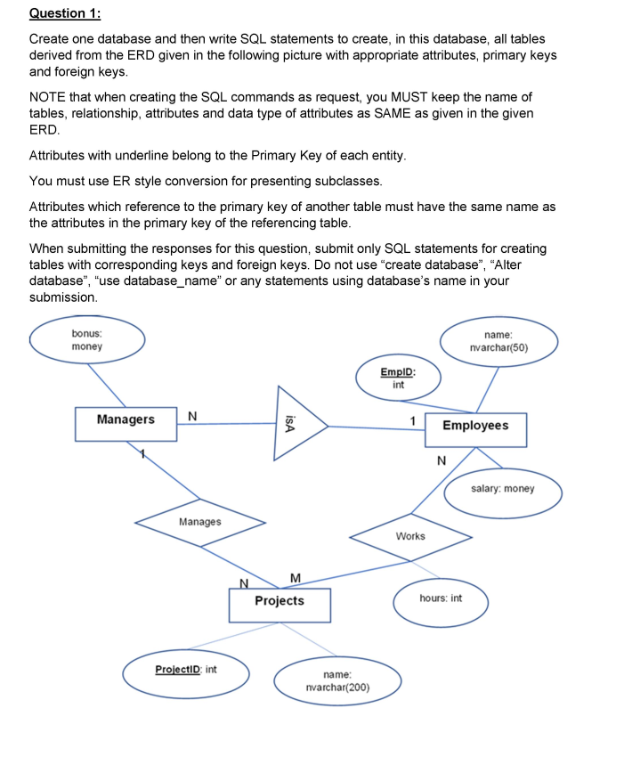

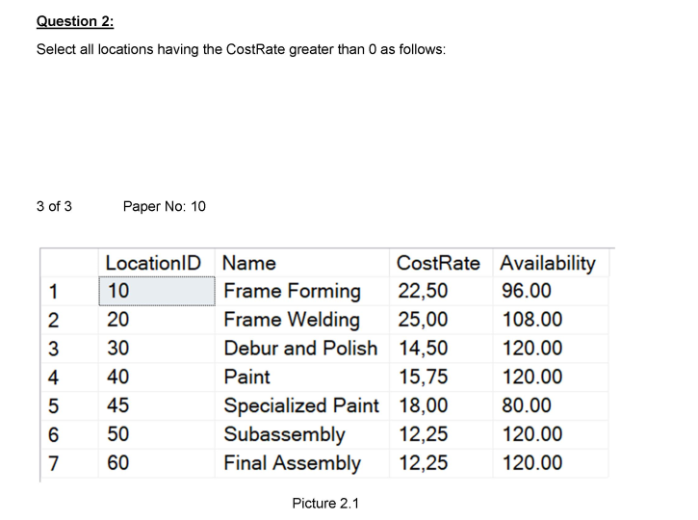

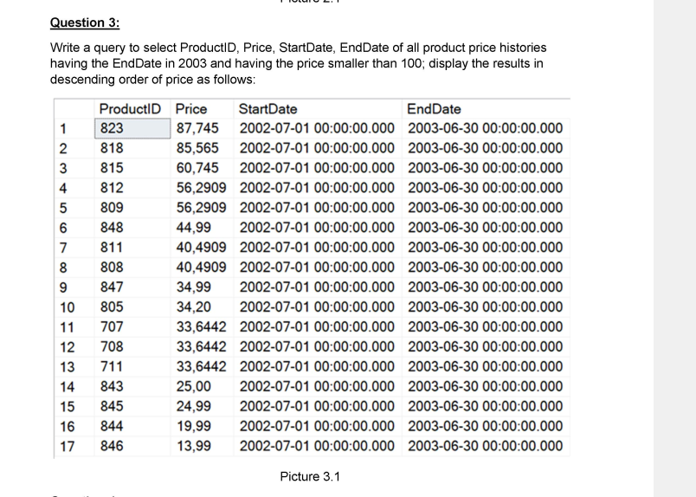

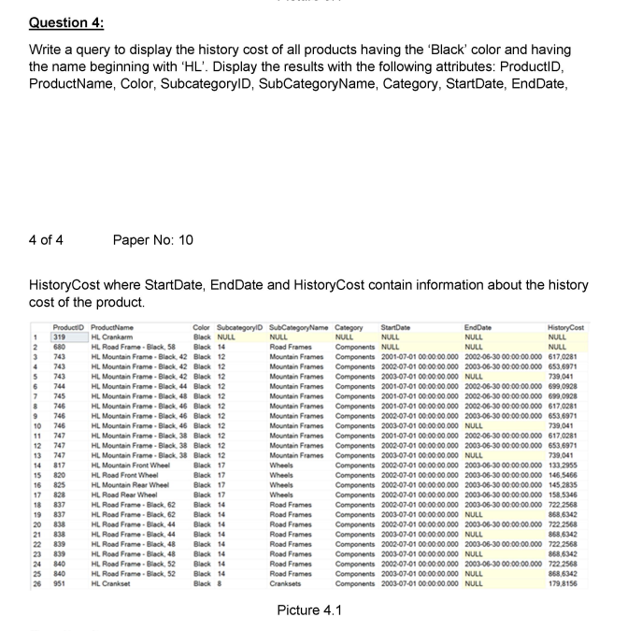

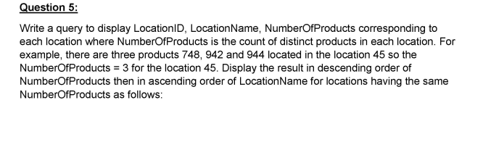

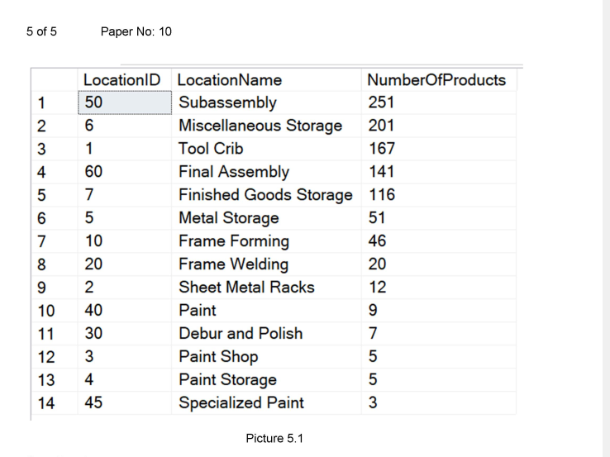

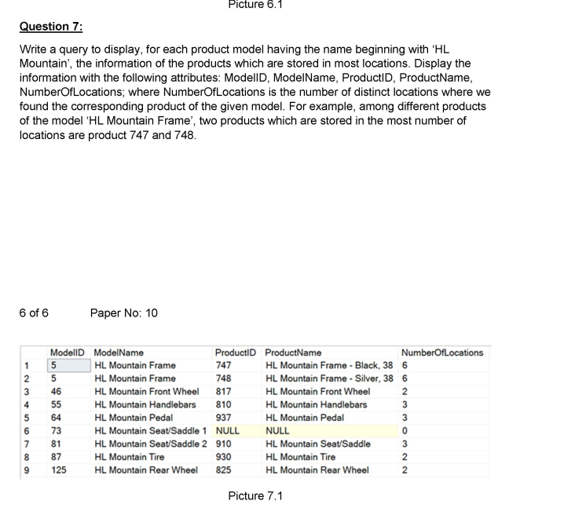

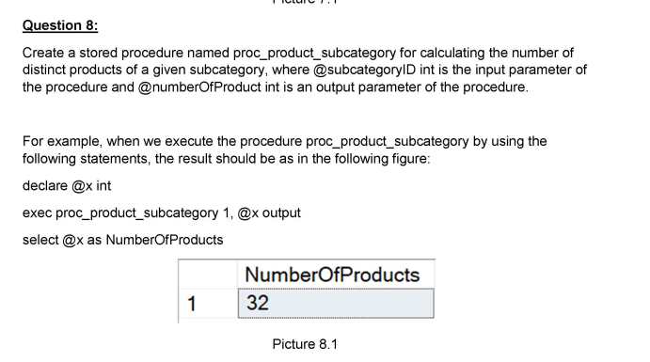

Create a stored procedure named **proc_product_subcategory** for calculating the number of distinct products of a given subcategory, where

* @subcategoryID int is the input parameter of the procedure
* @numberOfProduct int is an output parameter of the procedure.

For example, when we execute the procedure proc_product_subcategory by using the following statements, the result should be as in the following figure:

declare @x int

exec proc_product_subcategory 1, @x output

select @x as NumberOfProducts

